A computer is a machine that can store and process information. Most computers rely on a binary system, which uses two variables, 0 and 1, to complete tasks such as storing data, calculating algorithms, and displaying information. Computers come in many different shapes and sizes, from smartphones to supercomputers weighing more than 300 tons.
Analog computers
Analog computers use continuous physical magnitudes to represent quantitative information. At first they represented quantities with mechanical components (see differential analyzer and integrator), but after World War II voltages were used; by the 1960s digital computers had largely replaced them. Nonetheless, analog computers, and some hybrid digital-analog systems, continued in use through the 1960s in tasks such as aircraft and spaceflight simulation.
One advantage of analog computation is that it may be relatively simple to design and build an analog computer to solve a single problem. Another advantage is that analog computers can frequently represent and solve a problem in “real time”; that is, the computation proceeds at the same rate as the system being modeled by it. Their main disadvantages are that analog representations are limited in precision—typically a few decimal places but fewer in complex mechanisms—and general-purpose devices are expensive and not easily programmed.
Explore Britannica Premium!
The trusted destination for professionals, college students, and lifelong learners.

Digital computers
In contrast to analog computers, digital computers represent information in discrete form, generally as sequences of 0s and 1s (binary digits, or bits). The modern era of digital computers began in the late 1930s and early 1940s in the United States, Britain, and Germany. The first devices used switches operated by electromagnets (relays). Their programs were stored on punched paper tape or cards, and they had limited internal data storage. For historical developments, see the section Invention of the modern computer.
Mainframe computer
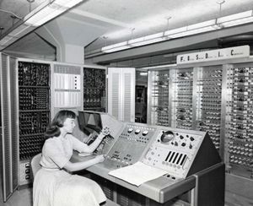
UNIVAC I, 1960A technician uses the UNIVAC I, made by Unisys, to scan census questionnaires.
During the 1950s and ’60s, Unisys (maker of the UNIVAC computer), International Business Machines Corporation (IBM), and other companies made large, expensive computers of increasing power. They were used by major corporations and government research laboratories, typically as the sole computer in the organization. In 1959 the IBM 1401 computer rented for $8,000 per month (early IBM machines were almost always leased rather than sold), and in 1964 the largest IBM S/360 computer cost several million dollars.
These computers came to be called mainframes, though the term did not become common until smaller computers were built. Mainframe computers were characterized by having (for their time) large storage capabilities, fast components, and powerful computational abilities. They were highly reliable, and, because they frequently served vital needs in an organization, they were sometimes designed with redundant components that let them survive partial failures. Because they were complex systems, they were operated by a staff of systems programmers, who alone had access to the computer. Other users submitted “batch jobs” to be run one at a time on the mainframe.
Such systems remain important today, though they are no longer the sole, or even primary, central computing resource of an organization, which will typically have hundreds or thousands of personal computers (PCs). Mainframes now provide high-capacity data storage for Internet servers, or, through time-sharing techniques, they allow hundreds or thousands of users to run programs simultaneously. Because of their current roles, these computers are now called servers rather than mainframes.
Supercomputer
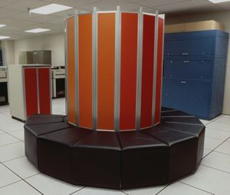
Cray-1 supercomputerThe supercomputer, which came out in 1976, was approximately 6 feet high and 7 feet in diameter (1.8 2.1 meters).
The most powerful computers of the day have typically been called supercomputers. They have historically been very expensive and their use limited to high-priority computations for government-sponsored research, such as nuclear simulations and weather modeling. Today many of the computational techniques of early supercomputers are in common use in PCs. On the other hand, the design of costly, special-purpose processors for supercomputers has been replaced by the use of large arrays of commodity processors (from several dozen to over 8,000) operating in parallel over a high-speed communications network.
Minicomputer
Although minicomputers date to the early 1950s, the term was introduced in the mid-1960s. Relatively small and inexpensive, minicomputers were typically used in a single department of an organization and often dedicated to one task or shared by a small group. Minicomputers generally had limited computational power, but they had excellent compatibility with various laboratory and industrial devices for collecting and inputting data.
One of the most important manufacturers of minicomputers was Digital Equipment Corporation (DEC) with its Programmed Data Processor (PDP). In 1960 DEC’s PDP-1 sold for $120,000. Five years later its PDP-8 cost $18,000 and became the first widely used minicomputer, with more than 50,000 sold. The DEC PDP-11, introduced in 1970, came in a variety of models, small and cheap enough to control a single manufacturing process and large enough for shared use in university computer centers; more than 650,000 were sold. However, the microcomputer overtook this market in the 1980s.

